**FREE GAS SERVICING – (HOME OWNERS)**

You must be a home owner to access this service and ALSO fit the criteria below –

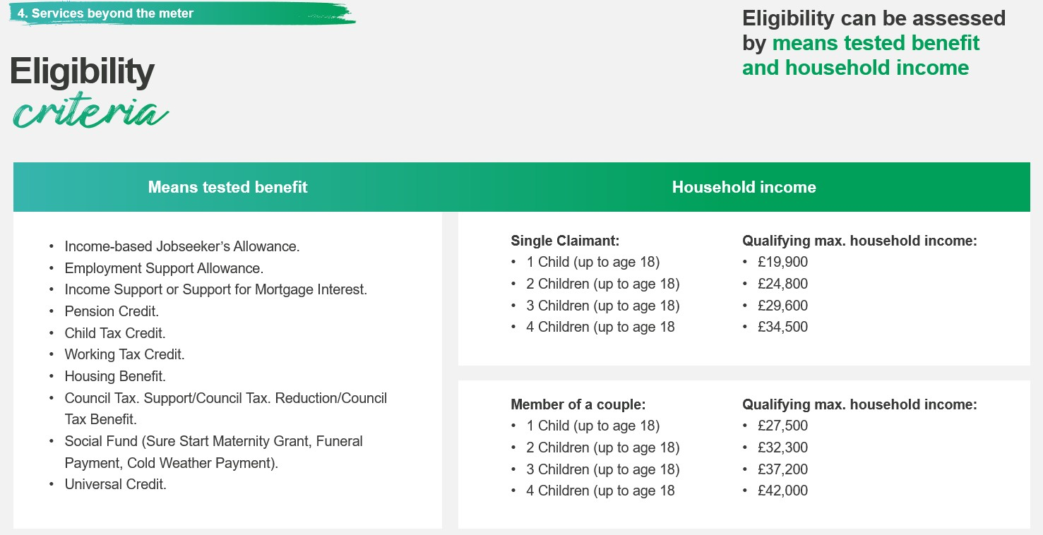

If you feel you are eligible please complete the form or give us a call at the centre – 0121 443 3310

|  |  |  |
| --- | --- | --- |
| Customer Name : | | |
| Customer Address and Post Code : | | |
| Contact number for Cadent to ring : | | |
| **1.Appliance**  (please confirm make and model) | Date of last service  (if now known put todays date) | Location of appliance  (living room, kitchen, dining room etc) |
| **2.Appliance**  (please confirm make and model) | Date of last service  (if now known put todays date) | Location of appliance  (living room, kitchen, dining room etc) |
| **3.Appliance**  (please confirm make and model) | Date of last service  (if now known put todays date) | Location of appliance  (living room, kitchen, dining room etc) |
| **4.Appliance**  (please confirm make and model) | Date of last service  (if now known put todays date) | Location of appliance  (living room, kitchen, dining room etc) |
| Tenure confirmed? (Private owned)  Please confirm that you do own your property | YES 🞏 Please tick to confirm | |
| Any welfare concerns on site ?  Which Benefits are you on? |  | |
| Signature of customer  If you are happy for us to pass these details to Cadent who will contact you within 10 working days to arrange a visit to complete your FREE gas service, please sign - | …………………………………………………….  Today’s Date : ………………………………………… | |

**FREE GAS SERVICING – (HOME OWNERS)**

**Completed form to be handed to JOANNE at Brandwood Centre**